An Approach to Estimating Bedrock and Surfaces Layers in Polar Radar Imagery

Jerome E. Mitchell¹, David J. Crandall¹, Geoffrey C. Fox¹, and John D. Paden²

¹School of Informatics and Computing, Indiana University – Bloomington, Bloomington, IN 47403 USA

²Center for Remote Sensing of Ice Sheets, University of Kansas, Lawrence, KS 66045 USA

This work estimates surface and bedrock layers from radar imagery acquired in Antarctica. Identifying and accurately selecting the surface and bedrock provides ice sheet thickness measurements, which are important for the study of ice sheets, their volume, and how they may contribute to global climate change. The time-consuming, manual approach, however, requires sparse hand-selection of surface and bedrock interfaces by several domain experts and interpolation between selections to save time. Given the petabytes of radar imagery acquired in the past and its growth each year, estimating bedrock and surface boundaries are necessary to provide results to the scientific community in a timely manner.

We have developed an active contours method (called level sets [1]) for estimating surface and bedrock layers in polar radar imagery. For each layer, a 2D embedding functions, $φ$, is initialized to an ellipse [5], so that its zero level set contains the contour of interest. Each ellipse has a center (u₁, v₁) and radii a and b.

$\frac{{\left(u-u_{1}\right)}^{2}}{a^{2}}$ + $\frac{{\left(v-v_{1}\right)}^{2}}{b^{2}}$ = 1
We define a function, f(u,v), to be zero for all points (u,v) lying on the ellipse. Therefore,

f(u,v) = $\frac{{\left(u-u_{1}\right)}^{2}}{a^{2}}$ + $\frac{{\left(v-v_{1}\right)}^{2}}{b^{2}}$ – 1 = 0
and an initial embedding function
$φ_{t=0}\left(x, y\right)$ = f(u,v)

The level set evolves iteratively in a direction normal to a gradient and is determined by a partial differential equation (Hamilton-Jacobi [4]) in order to minimize the cost function,
g(I) = $\frac{1}{{\left(1+| ∇ G_{σ}*I|\right)}^{2}}$ ,

where $G_{σ}$ represents a Gaussian kernel of standard deviation $σ$ and I representing the segmented bedrock and surface image. This cost function is minimized as it is inversely proportional to the gradient and acts as an edge stopping function with the gradient being maximum at object edges.

The value of embedding the embedding function $φ_{t+1}$ at any instant t+1 is expressed as

$φ_{t+1}$ = $φ_{t}$ + l$\frac{dφ}{dt}$ ,
where $φ_{t}$ is the value at instant t and l is the gradient descent step size.

As the function $φ$ evolves with time, the shape of its zero level set changes from an ellipse to the exact bedrock and surface topology. However, some numerical instabilities, such as sharp or flat shapes may occur, which may lead to computational inaccuracies and an improper result. A traditional way to avoid this problem focuses on using re-initialization to reshape $φ$ periodically after a number of iterations. The reinitialization function [3] used is:
$\frac{∂φ}{∂t}$ = S$\left(1-|∇φ|\right)$,
where S($φ$), a sign function using initial value of $φ$ may be expressed as

S$\left(φ\right)$ = $\frac{φ}{\sqrt{φ^{2}+ {\left(∆x\right)}^{2}}}$

Evolution of $φ$ automatically stops when its zero level set reaches the bedrock and surface layers because the cost function is minimized.

[6][7][8] have developed solutions for detecting targets in radar subsurface imagery, and although our method is depended on manually defining a simple ellipse for surface and bedrock layers, it saves a considerable amount of time from identifying complicated contours. Our approach will be applied to 827 ice thickness radar images and will be evaluated using the mean squared error with respect to hand-labeled ground-truth and [2]. The figure shows an example of an ice thickness echogram with detected bedrock (red) and surface layers (green).

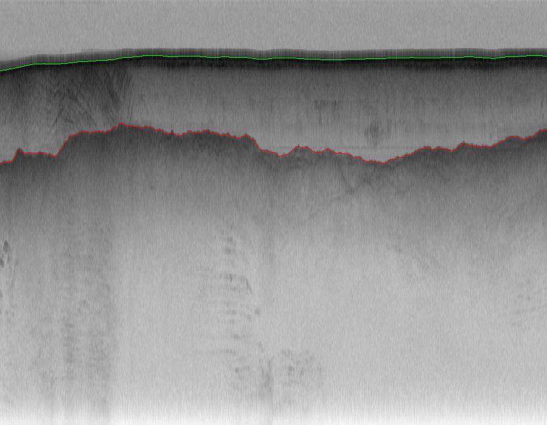

References
[1] S. Osher, J.A. Sethian, “Fronts propagating with curvature dependent speed: Algorithms based on Hamilton-Jacobi formulations,” J. Comput. Phys. vol. 79 Issue 1, 1988, 12-49.

[2] David J. Crandall, Geoffrey C. Fox, John D. Paden, “Layer-Finding in Radar Echograms using Probabilistic Graphical Models,” Proceedings of twenty-first conference of the International Association for Pattern Recognition (IPCR) 2012: 1530-1533.

[3] D. Peng, B. Merriman, S. Osher, H. Zhao, M. Kang, “A PDE based fast
local level set method,” J. Comp. Phys. Vol. 155, 1999, pp. 410-438.

[4] S. Osher, J.A. Sethian, “Fronts propagating with curvature dependent speed: Algorithms based on Hamilton-Jacobi formulations,” J. Comput. Phys. vol. 79 Issue 1, 1988, 12-49.

[5] P. Lipson, A. Yuille, D. Okeefe, J. Cavanaugh, J. Taaffe, and D. Rosenthal,
“Deformable Templates for Feature Extraction from Medical Images,” Proc. European Conf. Computer Vision, pp. 413-417, 1990.

[6] A. Ferro and L. Bruzzone. A novel approach to the automatic detection of subsurface features in planetary radar sounder signals. In IEEE Geo&Rem Sens. Symp., 2011.

[7] H. Frigui, K. Ho, and P. Gader. Real-time landmine detection with ground-penetrating radar using discriminative hidden markov models.

[8] G. Bruzzone et al. Subsurface radar sounding of the Jovian moon Ganymede. Proc. IEEE, 99:835–857, 2011.

